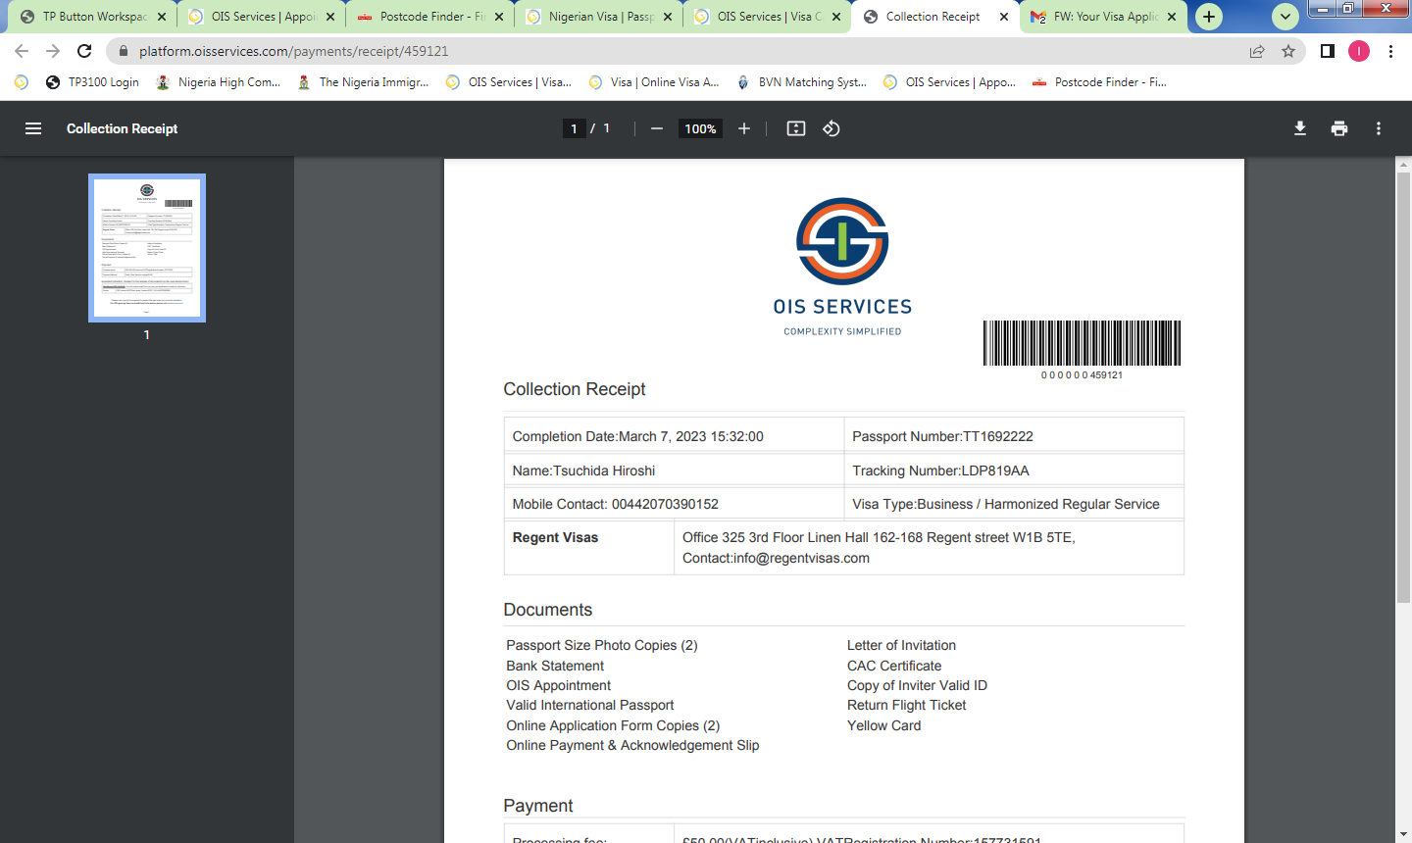
Spouse of Accredited Diplomat – R1B
R1B - Spouse of Accredited Diplomat Visa is issued to spouse of accredited Diplomats to Nigeria

Eligibility -
- Spouse of Accredited Diplomat

Please read this checklist and Important Information in full before you start completing the application form or book an appointment.
Tick when complete

1 | TRAVEL DOCUMENT:  Passport/Travel Document a minimum of 6 months validity at the time of travelling to and from Nigeria, with two blank facing pages.  Passport/Travel Document will be held by the mission until a decision has been made.
2 | PASSPORT SIZE PHOTOS:  Two recent UK passport sized photographs, taken no more than 2 weeks before submission, with applicant’s full name written on the back. (Photographs older than 1 month are not acceptable).
3 | ONLINE APPLICATION FORM:  Completed application form filled in and paid for online at  https://visa.immigration.gov.ng/  Once completed this must be printed out, in portrait.
4 | LETTER FROM NIGERIA MINISTRY OF FOREIGN AFFAIRS
5 | SUBMISSION:  All documents must be submitted to the Nigeria High Commission in London

